

**School of Electrical Engineering and Computing**

**Introduction mobile computing**

**Title: password guessing game**

**Section 3**

**Group members:**

Name Id group

1. Tedros h/slassie R/1118/08 6

2. Teklit fisseha R/1124/08 6

3. Surafel Zenebe R/1090/08 6

**Introduction**

Password guessing game is a kind of game that is played to guess a four-digit number password or pin. There are some rules to be consider when you choose the password or guess predicted password.so by using those rules, we can play the game in single player or multiplayer.

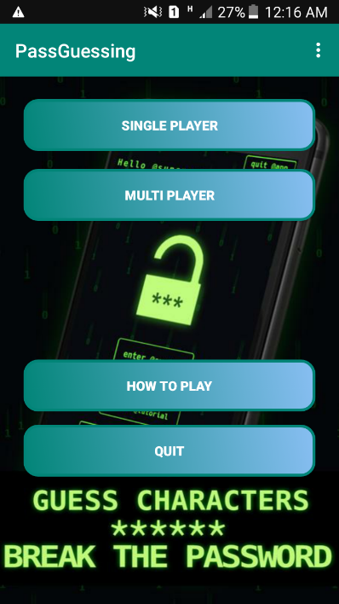

**Materials**

We use android studio application of a language java to work our project.

**Functionality of the application**

1. **In single player**, the password will be generated randomly then the objective is to guess the password. there are seven levers which is from level 0 – level 6. In each level, the rule for the password will vary and increase its strength when we increase our level.

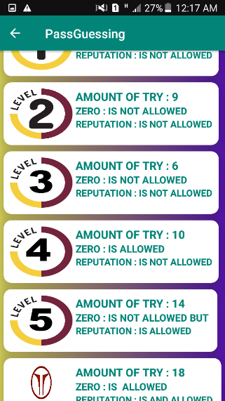 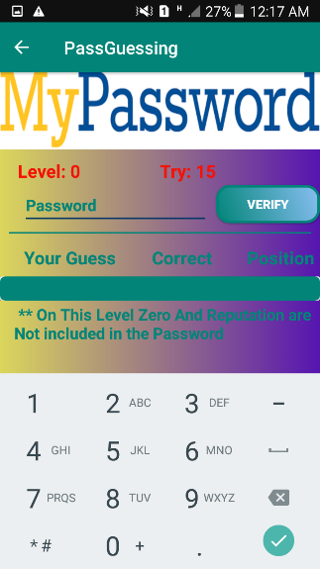

Levels of single player game zone of single player

**Rules of single player**

* **Level 0** the rules are the number must be 4 digit and zero and repetition is not allowed then you have to guess the password in 15.
* **Level 1** the rules are the number must be 4 digit and zero and repetition is not allowed then you have to guess the password in 12.
* **Level 2** the rules are the number must be 4 digit and zero and repetition is not allowed then you have to guess the password in 9.
* **Level 3** the rules are the number must be 4 digit and zero and repetition is not allowed then you have to guess the password in 6.
* **Level 4** the rules are the number must be 4 digit and zero is allowed and repetition is not allowed then you have to guess the password in 10.
* **Level 5** the rules are the number must be 4 digit and zero is not allowed and repetition is allowed then you have to guess the password in 14.
* **Level 6** the rules are the number must be 4 digit and zero and repetition is allowed then you have to guess the password in 18.

1. **In multiplayer**, two players will be played by using Bluetooth. First the two players have to connected using Bluetooth, then each player have to enter a password to start the game where the password must be 4 digit and zero and repetition is not allowed. After that the player who guessed the opponent password with minimum try will win.

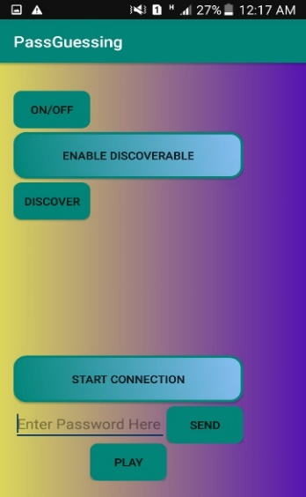 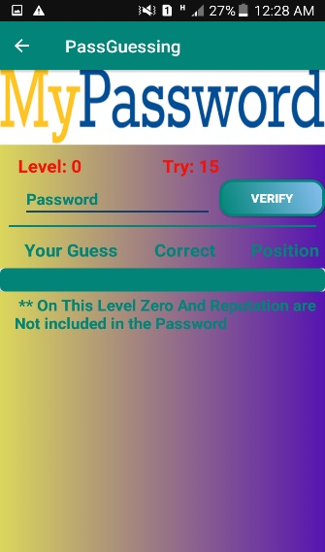

Connecting to Bluetooth and game zone of multiplayer

entering the password